
St Clare’s Catholic Primary School

Safeguarding Information for Visitors

Welcome
At St Clare’s Catholic Primary School, safeguarding is our highest priority. We want all children, staff, and visitors to feel safe, respected, and supported. This leaflet gives you important information about our safeguarding procedures while you are on site.

Our Commitment
- We are fully committed to keeping children safe.
- All staff and volunteers are trained in safeguarding and child protection.
- Concerns are always taken seriously and acted upon quickly.

Safeguarding Leads
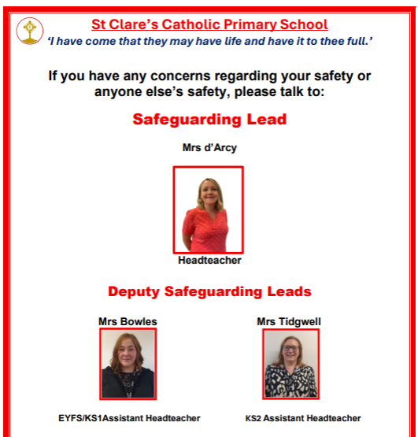
- Designated Safeguarding Lead (DSL) and Headteacher: Roxanne d’Arcy
- Deputy DSLs: Laura Bowles, and Claire Tidgwell

If you have ANY concerns about the welfare or safety of a child, please report them immediately to one of the above.

Visitor Responsibilities
- Sign in at reception and wear your visitor badge at all times.
- Do not use your mobile phone or take photographs/videos on school grounds.
- Remain with your host at all times unless otherwise authorised.
- Report immediately if you see or hear something that concerns you.

Fire Drill Procedures
– On hearing the fire alarm, leave the building immediately using the nearest safe exit.
– Do not stop to collect personal belongings.
– Do not use lifts.
– Visitors should follow staff instructions and exit calmly.
– Assemble at the designated fire assembly point on the school playground.
– Remain with your supervising staff member until the all-clear is given.

Lockdown Procedures
– On hearing the lockdown alarm/announcement, stay inside the nearest room.
– Close and lock doors and windows if safe to do so.
– Move away from sightlines, remain quiet, and switch phones to silent.
– Follow staff instructions at all times.
– Stay inside until an authorised member of staff or emergency services confirms it is safe to leave.

Recognising Concerns
You may see or hear something that worries you:
-A child appears neglected or distressed.
-A child makes a worrying comment.
-An adult behaves inappropriately towards a child.
👉 Do not investigate yourself.
👉 Report to the DSL or the school office immediately.

What to Do If a Child Discloses Something
- Listen carefully – do not interrupt.
- Do not promise confidentiality – explain that you must pass it on.
- Reassure the child that they have done the right thing.
- Report immediately to the DSL.

Emergencies
- If a child or adult is in immediate danger, call 999.
- Inform the school office/DSL straight away.

Safeguarding Principles
- Keeping Children Safe in Education (Statutory Guidance) underpins our approach.
- Safeguarding is everyone’s responsibility – staff, volunteers, and visitors alike.
- Together, we create a safe, nurturing environment where children can flourish.

Thank You
Thank you for supporting us in our commitment to safeguarding.
Your vigilance helps protect our children.
“Every child deserves to feel safe, valued, and loved.”

